File permissions in Linux
Project description
In this scenario, the research team needs to update the file permissions for certain files and directories within the projects directory. The permissions do not currently reflect the level of authorization that should be given. Checking and updating these permissions will help keep their system secure. To complete this task, I performed the following tasks
The following code demonstrates how I used Linux commands to determine the existing permissions set for a specific directory in the file system.
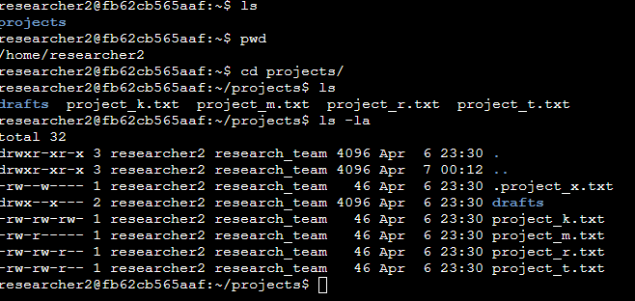

The organization determined that other shouldn't have write access to any of their files. To comply with this, I referred to the file permissions that I previously returned. I determined project_k.txt must have the write access removed for other. The chmod command changes the permissions on files and directories. The first argument indicates what permissions should be changed, and the second argument specifies the file or directory. In this example, I removed write permissions from other for the project_k.txt file, as well as removing the read permissions for the group in project_m.txt file After this, I used ls -la to review the updates I made.

The following code demonstrates how I used Linux commands to do this:

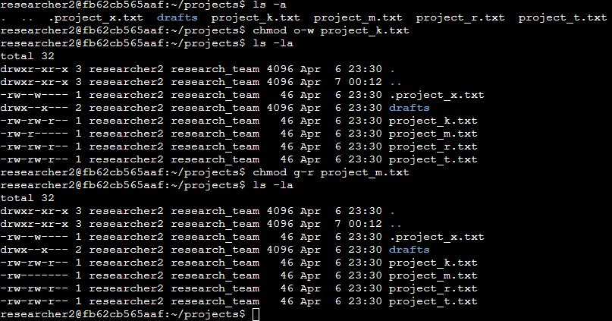

The organization only wants the researcher2 user to have access to the drafts directory and its contents. This means that no one other than researcher2 should have execute permissions. Here you can see that only researcher2 has execute permissions. It was previously determined that the group had execute permissions, so I used the chmod command to remove them. The researcher2 user already had execute permissions, so they did not need to be added.

The following code demonstrates how I used Linux commands to change the permissions:
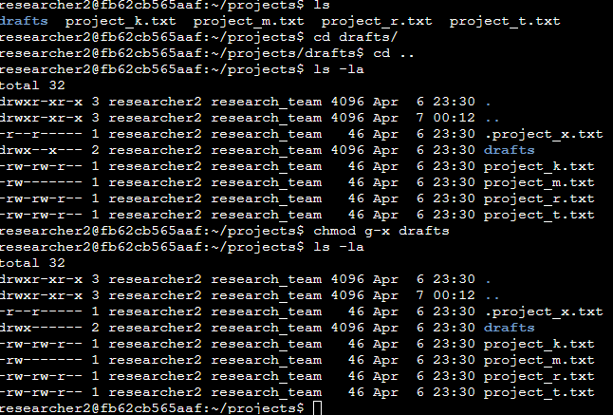

Summary
I changed multiple permissions to match the level of authorization the organization wanted for files and directories in the projects directory. The first step in this was using ls -la to check the permissions for the directory. This informed my decisions in the following steps. I then used the chmod command multiple times to change the permissions on files and directories.

